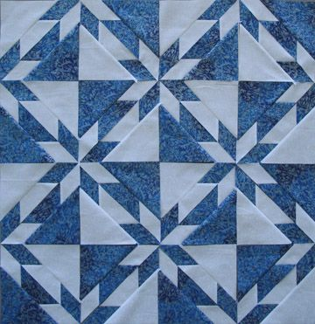
Brought to you by AQG
Hunter’s Star Class
With the Rapid Fire Hunter’s Star ™ from Studio 180 Design
Tuesday, December 6, 2022 10:00am-4:00pm Class Fee $50.00
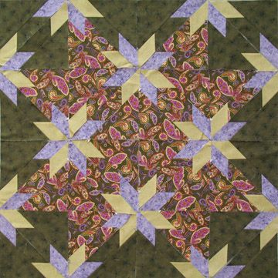
35th Avenue Sew and Vac
3548 W Northern Avenue
Phoenix, AZ 85051

Class Supply List
The Hunter’s Star quilt block is on many a Quilter’s Bucket List. Using Studio 180 Rapid Fire Hunter’s Star Tool you will want to make more than just one quilt. This class takes you through the basic steps for constructing the Hunter’s Star Block and then constructing them into a table topper or wall hanging size quilt included in the Rapid Fire Hunter’s Star tool instructions. The design will develop from the traditional two color setting to your unique setting of placing the blocks together. It is fun to see how the colors play with each other and the design begins to flow.

Project Supplies:
 Rapid Fire Hunter’s Star: Petite Star Template” from Studio 180 Design. (see below how to buy from Joyce). This includes all the instructions for 5”, 6” 7” or 8” blocks and two, three and four color waves. For this class, we will use the 7” size markings on the tool. See below for fabric requirements based on number of colors you will be using.
FABRIC: We will cut fabric in class
Traditional Two Color: 1 ½ yards dark for piecing and borders
1 ½ yards light for piecing and narrow border

Three Color Option: 1 ½ yards dark for piecing and borders
1 ¼ yards light for piecing and borders
1 yard star point fabric – keep in mind you are looking for contrast so the star
points pop.
Four Color Option: 1 ½” yards dark or Focus fabric for piecing and borders
1 yard light fabric for piecing
1 yard color 1 for star points and border
1 yard color 2 for star points and border accent

Basic Sewing Supplies:

6” x 12” ruler
Tucker Trimmer I or III not required but helpful
Invisagrip ™
Neutral color 100% cotton sewing thread 50 or 60 weight
Size 70/10 or 80/12 sewing machine needles
( I like to use a 70/10 Microtex Needle in my machine)
Rotary Cutter with a new blade (very helpful) and Rotary Cutting Mat
Thread Clips or small scissors for clipping threads
Best Press or Spray Starch
Fine Silk Pins
Mechanical pencil & Sharpie Ultra Fine Point Pen
Sewing Machine in GOOD Working order (if your machine has a 1/4” foot bring it along it will be most helpful)
An adventurous spirit - let’s have fun!

AQG in person Workshop “Hunter’s Star” Special pricing for Studio 180 Tools and other resources.

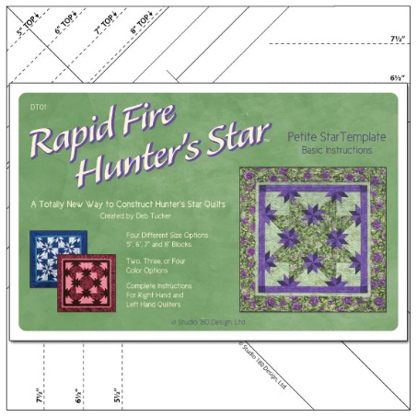
The Rapid Fire© Hunter’s Star tool and technique allow for streamlined construction and precision trim down and thus results in ease and accuracy when making these traditionally difficult blocks. There are multiple sizes on the tool, clearly illustrated step by step instructions, design layout options, and a “basic recipe” included to get quilters started on their first set of 16 blocks. The "basic recipe" has over 40 layout variations which can be seen in our Basic Recipe Razzle Dazzle photo gallery. This allows quilters to customize their projects right from the beginning so that each person can achieve that individualized look they so desire.
AQG special price for The Rapid Fire Hunter’s Star Petite Tool $29.00
Hidden Treasures.

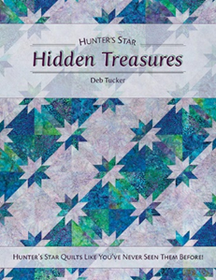
A Treasure Trove of Hunter's Star Designs!

Create unique designs using the Rapid Fire Hunter’s Star: Petite Star tool and Deb's streamlined construction techniques. All projects are made using the same size block and a simple fabric formula. The results will amaze you! Spark your creative side with these innovative designs. You'll soon find yourself discovering the Hidden Treasures in your Hunter's Star projects!
AQG special price for “Hunters Treasures” $26.85

SPECAIL AQG Price package for both Rapid Fire Hunter’s Star Tool and Hidden Treasures: $52.75 a 17% discount.

Contact
Joyce Holley
Noah & Her Sisters Quilt Co.
939 W Palma De Pina
Tucson, AZ 85704
816-223-4454 Quiltwithme2@comcast.net
Website: Noahsisterquilts.com
Facebook: Noah& Her Sisters Quilt Co.

